The Greenhouse Effect
&
Weather vs. Climate

Learning Target 2: I can describe the greenhouse effect and factors affecting it.

Assessment OF Learning

Name:_________________________________________________
Date:____________________________
Section:________________
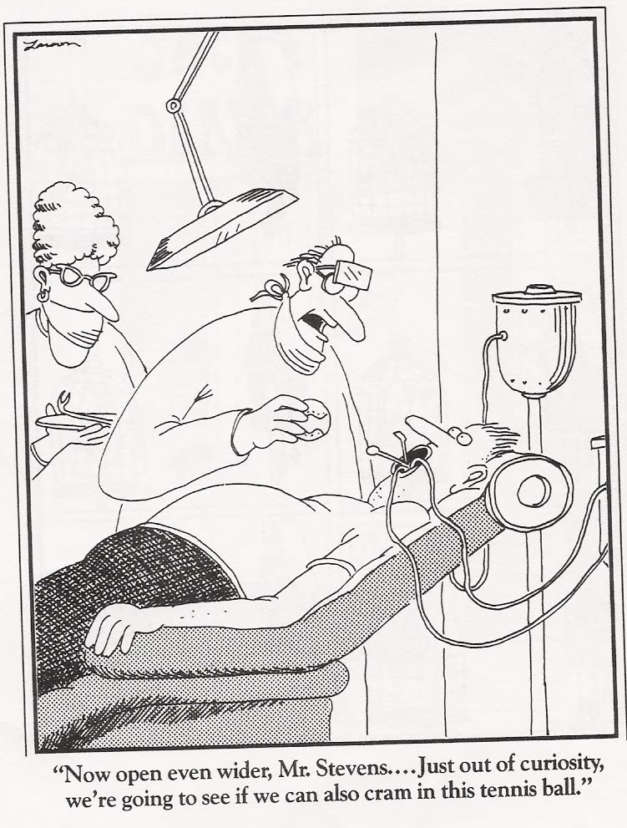
Take your time, and do your best!

Greenhouse Effect
- Define the greenhouse effect:
________________________________________________________________________________________________________________________________________________________________________________________________________________________________________________________________________________________________
- Define greenhouse gases:
________________________________________________________________________________________________________________________________________________________________________________________________________________________________________________________________________________________________
- List 3 greenhouse gases, and describe AT LEAST 2 sources. Each correct additional source will earn you an extra half point!
  - _____________________________________________________
  - _____________________________________________________
  - _____________________________________________________
- Describe the differences between “good” ozone and “bad” ozone. Make sure you include the layer of the atmosphere in which it is located and the impact it has on Earth.

- Draw and describe the greenhouse effect. Make sure you include the following labels: Sun ~ Earth ~ Troposphere ~ Stratosphere ~ Ozone ~ Greenhouse Gases (GHGs) ~ Ultra-violet Radiation (short-wave) ~ Reradiated Infrared Radiation (long~wave)

Weather and Climate
- The atmospheric conditions of weather and climate can be described by terms, such as (name at least 3):_________________________________
________________________________________________________,
but weather is _________________ and climate is _________________.

Label the following scenarios as weather or climate.
- This past Sunday was a perfect fall day with clear blue skies and brightly colored leaves.
- It is unusual for Springfield and the surrounding areas to get tornadoes, yet we have been seeing them more frequently.

- This week is supposed to be rainless until Thursday.

- Ms. Hale is often unsure if she would prefer to live in an area that gets lots of snow or lots of sun.

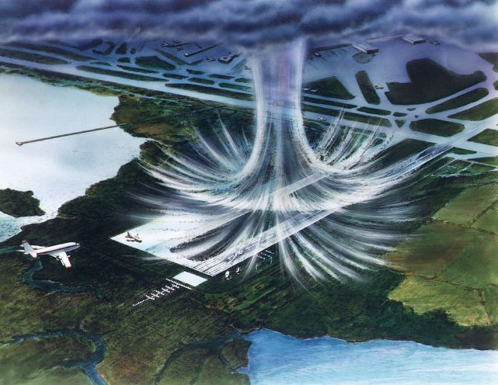
- A microburst is a very localized column of sinking air caused by a small and intense downdraft within a thunderstorm, but the air does not spin like it does in a tornado.

