|  |  |
| --- | --- |
| **Layers of the Atmosphere**  Fill in the names of the layers of the atmosphere in the left hand column of the chart below. | **Importance**  Describe at least **TWO** important facts about each layer. |
| **1)_______________________**  **Up to 6,200 miles (10,000 km)** | 2)  3) |
| **4)_______________________**  **Up to 375 miles (600 km)** | 5)  6) |
| **7)_______________________**  **Up to 56 miles (90 km)** | 8)  9) |
| **10)_______________________**  **Up to 31 miles (50 km)** | 11)  12) |
| **13)_______________________**  **Up to 12 miles (20 km)** | 14)  15) |

Name:___________________________________ Date:_____________________

**Earth Systems Study Guide**

Learning Target 1: ______________________________________________

____________________________________________________________

16) Describe why the ozone layer is important for the earth.

________________________________________________________________________________________________________________________________________________________________________________________________________________________________________________________________________

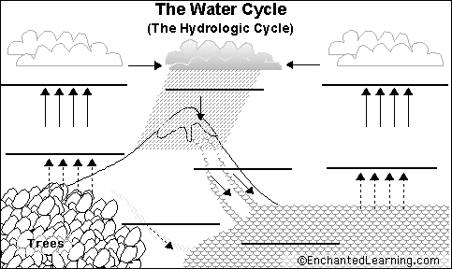17-24) Using the following terms, fill out the diagram below. **One** word will be used **twice**.

Precipitation

Condensation

Condensation, Evaporation, Infiltration, Runoff, Surface Water, Precipitation, Transpiration

25) Describe the relationship between precipitation, runoff, and infiltration.

__________________________________________________________________________________________________________________________________________________________________________________________________________________________________________________________________________________________________________________________________________

26-30) **BALANCED** CHEMICAL EQUATION OF PHOTOSYNTHESIS: Complete with the following word bank:

C6H12O6 (sugar), H2O (water), CO2 (carbon dioxide), O2 (oxygen), Sunlight

__________ + ___________ ___________ + ___________

31) USING COMPLETE SENTENCES, explain what the equation above represents. Make sure you include and explain any components not expressed in this equation.

32-37) **BALANCED** CHEMICAL EQUATION OF CELLULAR RESPIRATION: Complete with the following word bank:

C6H12O6 (sugar), H2O (water), CO2 (carbon dioxide), O2 (oxygen), ATP (energy), heat

_______ + _______ _______ + _______ + _______+ _______

38) USING COMPLETE SENTENCES, explain what the equation above represents. Make sure you include and explain any components not expressed in this equation.

39) In complete sentences, describe how the biosphere you constructed represents an interaction between the biosphere, hydrosphere, lithosphere, and atmosphere.

______________________________________________________________________________________________________________________________________________________________________________________________________________________________________________________________________________________________________________________________________________________________________________________________________________________________________________________________________________________________________________________________________________________________________________________________________________________________________________________________________________________________________________________________________________________________________________________________________________________________________________________________________________________________________________________________________________________________________________________________________________________________

Identify which systems are interacting in the pictures, and explain how they are interacting.

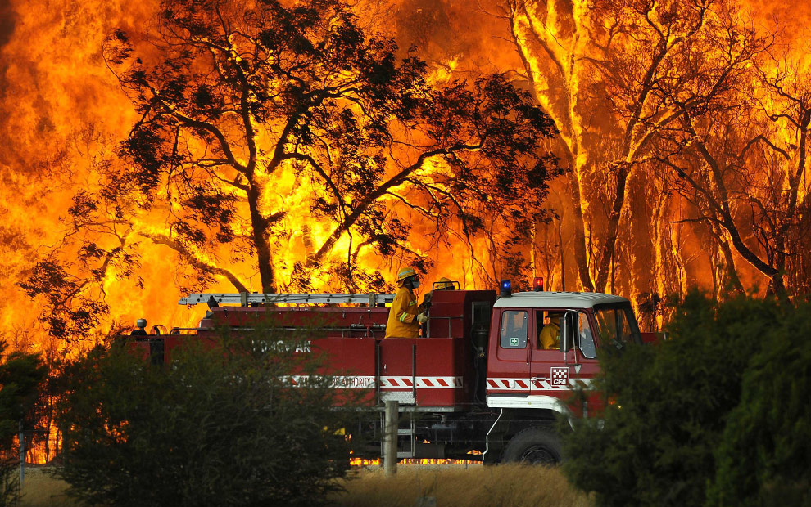40) Systems Interacting:__________________________________

41)Explanation:______________________________________________________________________________________________________________________________________________________________________________________________________________________________________________________________

^A forest fire

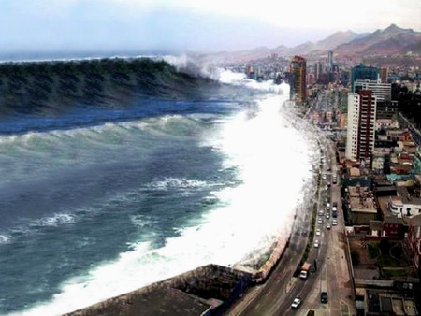42) Systems Interacting:__________________________________

43)Explanation________________________________________________________________________________________________________________________________________________________________________________________________________________________________________________________________________________________________________________________________________________________________________

^A tsunami (giant wave crashing into a city)

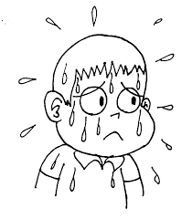

44) Systems Interacting:___________________________________________

45) Explanation: _________________________________________________

______________________________________________________________________________________________________________________________________________________________________________________________________________________________________________________________________________________________________________________

^Sweating

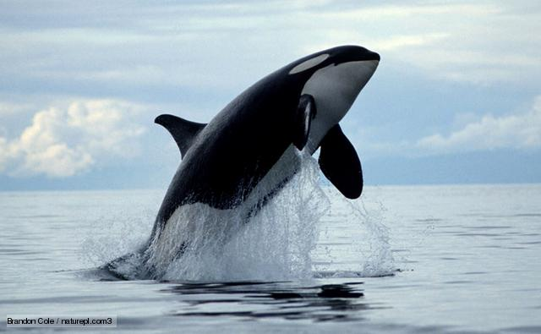46) Systems Interacting:_________________________________

47)Explanation: ________________________________________

____________________________________________________________________________________________________________________________________________________________________________________________________________________________________________________________________

^An orca (killer whale) jumping out of the ocean

|  |
| --- |
| Other study strategies for success on the upcoming LT1 Earth Systems Test:   1. Review your vocabulary tracker. Make sure it is complete!!! Check the vocabulary list on the Word Wall. 2. Review your quizzes as an additional study guide. Not everything you need to know for the test is on this study guide. 3. You may want to create FLASH CARDS. |